Content words

📘 What Are Content Words?
# Source: AI Source: Provided by: [Data Path: Persons Table -> ID Column: 1, Name_En Column: Motasem Essam] -> From: [Chatgpt (GPT-4-turbo)] on [7/24/2025]
Content words are words that carry the main meaning in a sentence.
They belong to the open class of words, meaning new words can be added to these categories over time.

🧠 Main Categories of Content Words:
# Source: AI Source: Provided by: [Data Path: Persons Table -> ID Column: 1, Name_En Column: Motasem Essam] -> From: [Chatgpt (GPT-4-turbo)] on [7/24/2025]
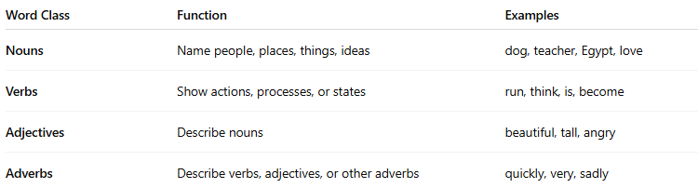
Word Class | Function | Examples
Nouns | Name people, places, things, ideas | dog, teacher, Egypt, love
Verbs | Show actions, processes, or states | run, think, is, become
Adjectives | Describe nouns | beautiful, tall, angry
Adverbs | Describe verbs, adjectives, or other adverbs | quickly, very, sadly

✳️ Key Characteristics of Content Words:
# Source: AI Source: Provided by: [Data Path: Persons Table -> ID Column: 1, Name_En Column: Motasem Essam] -> From: [Chatgpt (GPT-4-turbo)] on [7/24/2025]
- Carry lexical meaning
- Can be stressed in speech
- New words can be created (e.g. slang, tech terms)
- Flexible — can stand alone and still convey meaning
- Typically more "important" to the core idea of the sentence

✅ Examples in Sentences:
# Source: AI Source: Provided by: [Data Path: Persons Table -> ID Column: 1, Name_En Column: Motasem Essam] -> From: [Chatgpt (GPT-4-turbo)] on [7/24/2025]
- The cat sleeps.
→ cat (noun), sleeps (verb) = content words
- He ran quickly.
→ ran (verb), quickly (adverb) = content words
- That was a beautiful painting.
→ beautiful (adjective), painting (noun) = content words

🆚 Content Words vs Function Words
# Source: AI Source: Provided by: [Data Path: Persons Table -> ID Column: 1, Name_En Column: Motasem Essam] -> From: [Chatgpt (GPT-4-turbo)] on [7/24/2025]
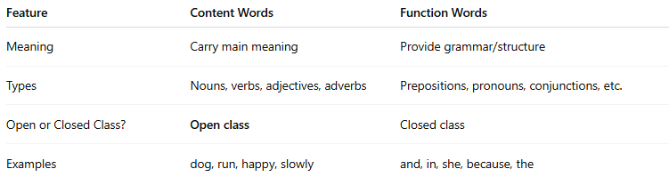
Feature | Content Words | Function Words
Meaning | Carry main meaning | Provide grammar/structure
Types | Nouns, verbs, adjectives, adverbs | Prepositions, pronouns, conjunctions, etc.
Open or Closed Class? | Open class | Closed class
Examples | dog, run, happy, slowly | and, in, she, because, the

✅ Summary:
# Source: AI Source: Provided by: [Data Path: Persons Table -> ID Column: 1, Name_En Column: Motasem Essam] -> From: [Chatgpt (GPT-4-turbo)] on [7/24/2025]
Content words are the core vocabulary that express ideas and actions.
They include nouns, verbs, adjectives, and adverbs, and are essential to the meaning of a sentence.

